Rendezvous 2024
Silent Auction
Louisiana Room
Abe Pierce III Convention Center @ Monroe Civic Center

April 12-13
Donation: Any item with natural history or conservation theme!
apparel, hats, t-shirts, field gear, plants, art, jewelry ++

Contact: Suzanne Laird Dartez, slaird61@yahoo.com

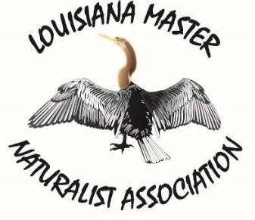
LMNA fundraiser

